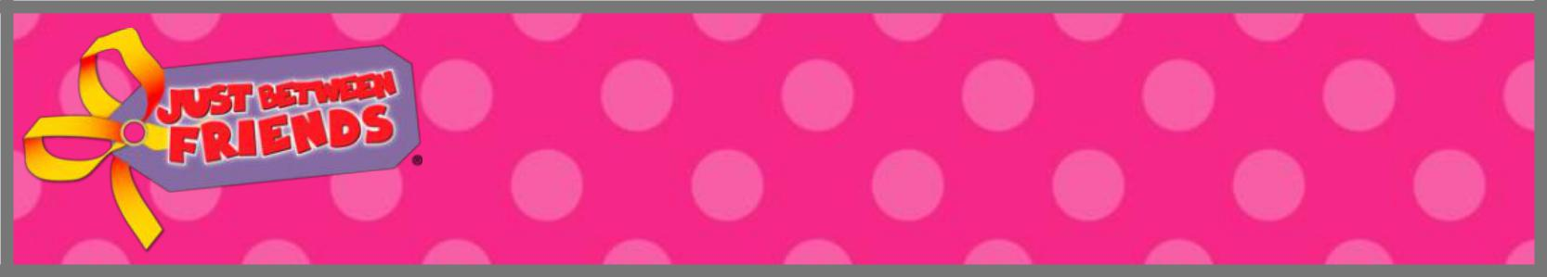
What we Accept at
SPRING Sales

The following are accepted at the Eagan/Apple Valley Spring Sales

CLOTHING: Spring/Summer Styles
Newborn-Size 20 & junior clothing

Spring & Summer appropriate styles; Easter & Patriotic holidays
Shorts & capris, lightweight pants, jeans
Short sleeve shirts & onesies
Long sleeve shirts & button up long sleeve shirts:
in lightweight fabric
Sweatshirts: zip-up, hoodie & fleece
Pajamas: short & long sleeve pajamas in summer weights (NO fleece)
Spring/Summer dresses & skirts (NO corduroy)
Swimsuits (bikinis size 10 & under need both pieces), swim cover ups
Cotton & fleece sleep sacks
Spring jackets & raincoats
Accessories: socks, thin tights, hats, belts, clean underwear, bras, ties, hair bows, hair accessories, jewelry, sunglasses
Dress up/play outfits

SHOES: Infant-Size 8 in like NEW shape!

Tennis shoes, water shoes, Robeez/similar type soft shoes, rainboots, cowboy boots, Crocs (NO fur-lined in Spring), sandals
Girls dress shoes (NO black leather/patent)
Boys dress shoes in any color
Slippers: lightweight, open toe or open back only

ELECTRONICS:

Dvd’s that are G. PG, PG-13 in original cases, Music CDs
Games for Xbox, Playstation, Wii, DS etc.
Leap pad and Leap reader type systems/books
Ipods, Ipads, DS, ds cases, game systems

BABY ITEMS:
Nipples, pacifiers and plastic bottles - only NEW and in original package accepted. (NO used nipples with bottles, or sippy cups). Feeding items– bibs, glass bottles, sippy cups (hard spout), plates, utensils. Boppy pillows, Bumbo chairs with safety straps, crib mobiles, monitors, safety items. Diaper bags, clean cloth diapers & covers, disposable diapers, bath toys, like new bath towels, baby bathtubs. Baby carriers, slings, wraps, shopping cart covers, car seat covers, car seat toys and accessories. Nursing bras, nursing covers, Unexpired formula that doesn’t say “not for resale” on package.

BOOKS: Kids Books Only!

(Only books meant for KIDS to read or be read, not books for a parent to learn from or teach from)

Soft/fabric books, board books, picture books, easy readers,
chapter books, kid’s non-fiction, CD audio books.
Kid cookbooks, bibles, dictionaries and encyclopedias
ANY holiday books

TOYS, GAMES, PUZZLES & CRAFTS:
Toys for all ages with ALL parts, working batteries & clean
Kid/Family Games with ALL pieces and original boxes, no baggies Kid/Family Puzzles with ALL pieces and original boxes, no baggies
Kids craft books, NEW coloring books or workbooks
Craft kits with essential items
Stuffed animals that move/walk/talk
Current licensed stuffed characters at least 12” or bigger

SPORTING GOODS:
Bikes, trikes & scooters, bike trailers & tag along, roller blades
Baseball gloves, bats, cleats, soccer gear; swim toys, life jackets;
Like NEW beach towels
Dance/tap/ballet shoes & dance costumes

BEDDING & ROOM DECOR:
Bassinet, changing pad covers, crib & toddler size sheets only
Receiving blankets: ONLY small receiving or swaddling type blankets, plus gauze/muslin type blankets
Room Décor: lamps, night lights, clocks, pillow pets, fashion pillows sleeping bags, rugs, kids picture frames, kid’s room wall décor, kid’s shelves or storage bins

BABY EQUIPMENT:
Lay under mats, bouncers, exersaucers, jumperoos, walkers, swings, highchairs, changing tables, strollers, rocking chairs, pack n play, bassinets, crib mattresses, booster seats

FURNITURE & LARGE TOYS
Glider/rockers, kid’s dressers, kid desks, toddler beds, toy boxes,
twin headboards, picnic tables, bookshelves, train tables, foosball tables, toy organizers, step stools, cozy coupe cars, wagons, tents

Sorry, We CAN’T Accept: |  | We reserve the right to pull any items we deem inappropriate or too high priced for the sale.
-Any stained items or things without batteries | -Dollar store type items or Happy Meal type toys
-Anything missing any parts or pieces | -Inclined sleepers (like Rock & Play – all brands)
-Cribs, crib bumpers or wedges | -VHS tapes, R or M rated movies | Remember our recommended priced “sweet”  spot is 1/4-1/3 of retail. Please price items
-Any recalled items | -Party Supplies, Homemade items, or Mommy Mart items
-Breast pumps or accessories | -Bedding sets for any size bed | accordingly!
-Infant Car Seats | -Football or hockey helmets
-Used nipples, pacifiers, plastic bottles | -Parenting/baby/homeschooling curriculum or materials
 | -Adult scrapbooking or stamping supplies
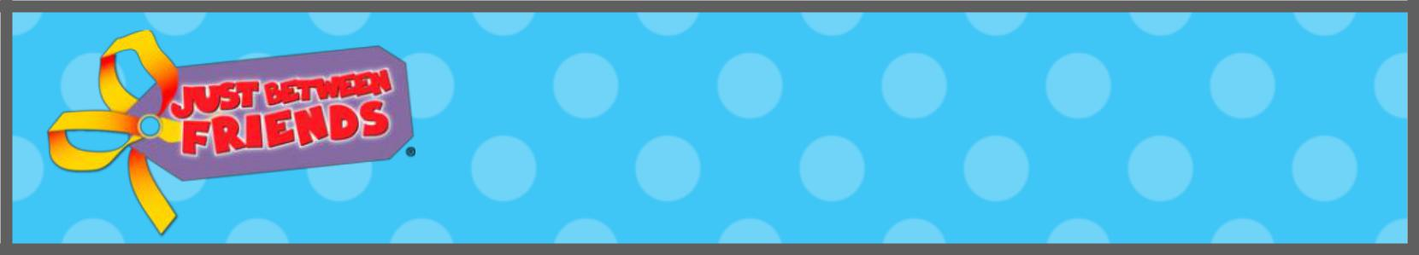
What we Accept at
FALL Sales

The following are accepted at the Eagan/Apple Valley Fall Sales

CLOTHING: Fall/Winter Styles

Newborn-Size 20 & junior clothing

Fall & Winter appropriate styles; Halloween, Thanksgiving,
Christmas & Valentine’s holidays
Jeans & long pants (NO capris or shorts)
Short sleeve shirts ONLY for sizes 5 and up!
Long sleeve shirts, onesies & sweatshirts
Pajamas (all types)
Fall/Winter dresses & skirts (including corduroy)
Swimsuits (bikinis size 10 & under need both pieces), swim cover ups
Onesies: Short sleeve onesies with envelope neckline ONLY (used as under shirt)
Cotton & fleece sleep sacks
Fall jackets, puffy vests, raincoats
Winter jackets, snow pants, hats, mittens, scarfs
Accessories: socks, all tights, hats, belts, clean underwear, bras, ties, hair bows & accessories, jewelry, sunglasses, fashion scarfs
Dress up/play outfits & Halloween costumes

SHOES: Infant-Size 8 in like NEW shape!

Tennis shoes, water shoes, Robeez/similar type of soft shoes, rainboots, cowboy boots, all Crocs, winter boots, tall fashion boots, all slippers
Girls dress shoes (NO white leather/patent)
Boys dress shoes in any color

ELECTRONICS:

Dvd’s that are G. PG, PG-13 in original cases, Music CDs
Games for Xbox, Playstation, Wii, DS etc.
Leap pad and Leap reader type systems/books
Ipods, Ipads, DS, ds cases, game systems

BABY ITEMS:

Nipples, pacifiers and plastic bottles - only NEW and in original package accepted. Feeding items– bibs, glass bottles, sippy cups (hard spout), plates, utensils. Boppy pillows, Bumbo chairs with safety straps, crib mobiles, monitors, safety items. Diaper bags, clean cloth diapers & covers, disposable diapers, bath toys, like new bath towels, baby bathtubs. Baby carriers, slings, wraps, shopping cart covers, car seat covers, car seat toys and accessories. Nursing bras, nursing covers, Unexpired formula but can’t say “not for resale” on package.

Sorry, We CAN’T Accept: |  | We reserve the right to pull any items we deem inappropriate or too high prices for the sale.
-Any stained items or things without batteries | -Dollar store type items or Happy Meal type toys
-Anything missing any parts or pieces | -Inclined sleepers (like Rock & Play – all brands)
-Cribs, crib bumpers or wedges | -VHS tapes, R or M rated movies | Remember our recommended priced “sweet”  spot is 1/4-1/3 of retail. Please price items
-Any recalled items | -Party Supplies, Homemade items, or Mommy Mart items
-Any recalled items | -Party Supplies, Homemade items, or Mommy Mart items | accordingly!
-Breast pumps or accessories | -Bedding sets for any size bed | accordingly!
-Infant Car Seats | -Football or hockey helmets
-Used nipples, pacifiers, plastic bottles | -Parenting/baby/homeschooling curriculum or materials
-Sandals of any kind | -Adult scrapbooking or stamping supplies

BOOKS: Kids Books Only!

(Only books meant for KIDS to read or be read, not books for a parent to learn from or teach from)
Soft/fabric books, board books, picture books, easy readers,
chapter books, kid’s non-fiction, CD audio books,
Kid cookbooks, bibles, dictionaries and encyclopedias
ANY holiday books

TOYS, GAMES. PUZZLES, ARTS & CRAFTS:
Toys for all ages with ALL parts, working batteries & clean
Kid/Family Games with ALL pieces and original boxes, no baggies Kid/Family Puzzles with ALL pieces and original boxes, no baggies
Kids craft books, NEW coloring books or workbooks
Craft kits with essential items
Stuffed animals that move/walk/talk
Current licensed stuffed characters at least 12” or bigger

SPORTING GOODS:
Bikes, trikes & scooters, bike trailers & tag along, roller blades
Baseball gloves, bats, cleats, soccer gear; swim toys, life jackets;
Like NEW beach towels
Ice skates, dance/tap/ballet shoes & dance costumes

BEDDING & ROOM DECOR:
Bassinet, changing pad covers, crib & toddler sheets only
Receiving blankets: ONLY small receiving or swaddling type blankets, plus gauze/muslin type blankets
Room Décor: lamps, night lights, clocks, pillow pets, fashion pillows, sleeping bags, rugs, kid’s picture frames, kid’s room wall décor, kid’s shelves or storage bins

BABY EQUIPMENT:
Lay under mats, bouncers, exersaucers, jumperoos, walkers, swings, highchairs, changing tables, strollers, rocking chairs, pack n play, bassinets, crib mattresses, booster seats

FURNITURE & LARGE TOYS
Glider/rockers, kid’s dressers, kid desks, toddler beds, toy boxes, twin headboards, picnic tables, bookshelves, train tables, foosball tables, toy organizers, step stools, cozy coupe cars, wagons, tents

